Homework for General physics II Set5

1. Hecht, problem 11.10. (You may need the representation of the Dirac delta function and its properties, and if you use the symmetrical Fourier Transform I preferred in the class, then there will be no 2π)
2. Prove that convolution defined is commutable for functions g and h, i.e.:

 are same.

1. Prove the convolution theorem of the Fourier Transform. i.e $g(x)⊗h(x)⇌G(κ)H(κ)$ (the proof is in the Hecht’s book and in my lecture but please try it yourself)
2. Hecht’s 11.22
3. Hecht’s 11.25
4. Hecht’s 11.28 (It is effectively a 3 slits grating, you may compare the Fourier result with the multi-slits’ result, they are same)
5. Hecht’s problem 11.35 (This is basically use the results in Zhao’s book, table V-3, from results 2 and 9 to prove result 8. The convolution theorem in the class is that if the original function is the convolution of two functions, then its Fourier Transform is the product of individual transform; here the situation is reversed, the original function is the product, you may verify that the transform will be the convolution of the individual transforms)
6. For a 4F system, the focal lengths are 10cm, the diameters of the lenses are 5 cm, the wavelength of light in use is 500 nm, what is the minimum structure of the object that can be resolved in the image formed by such system? (i.e the smallest linear feature of the object that can be resolved on the image)

Recommended problems in Zhao’s book(Vol.2) Problem 6, 13, 14; pg. 111-112: problems 2, on pg .127. (no need to hand-in for these extra practices)

1. (Optional) This problem is designed to help you knowing the ellipse (for the elliptical polarized light)

For a elliptical polarization given by: $\left[\begin{matrix}A \\ Be^{iφ}\end{matrix}\right]$, as derived in the Hecht’s book (Pg. 328, relation 8.14) The H-V component of Electric field amplitude $E_{x}, E_{y}$ satisfy:

$\frac{E_{x}^{2}}{A^{2}}+\frac{E_{y}^{2}}{B^{2}}-2\left(\frac{E_{x}}{A}\right)\left(\frac{E_{y}}{B}\right)cosφ=\sin^{2}φ$ This is a tilted ellipse and in this problem you are going to find the angle of the major axis of the ellipse (Hecht’s relation 8.15) and also the short-long axis length of the ellipse.

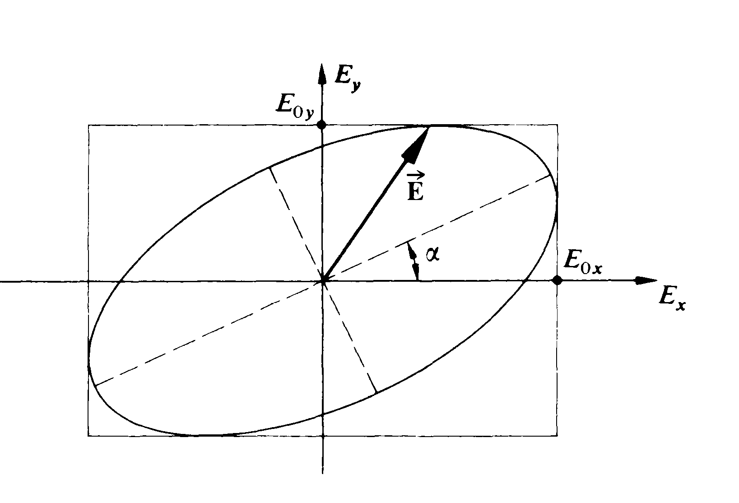

1. Start writing the relation in standard polynomial form of the conic section curves: Let x, y stand for $E_{x}, E_{y}$ to save some writing. Rewrite the relation $\frac{E_{x}^{2}}{A^{2}}+\frac{E_{y}^{2}}{B^{2}}-2\left(\frac{E_{x}}{A}\right)\left(\frac{E_{y}}{B}\right)cosφ=\sin^{2}φ$ into forms of $ax^{2}+bxy+cy^{2}+dx+ey+f=0$. What is the coefficient of a,b,c,d,e,f in terms of A,B, $φ$?
2. Suppose we now rotate the coordinate axis by angle $α$; find out the expression of the ellipse $ax^{2}+bxy+cy^{2}+dx+ey+f=0$ in terms of new coordinate $x^{'},y'$. i.e. In the new coordinate the expression would be: $a'{x^{'}}^{2}+b'x'y'+c'{y^{'}}^{2}+d'x+e'y+f'=0$; what are the relations between the a’,b’,c’… with a,b,c.
3. To find out the angle of $α$, i.e. in the new coordinate, the ellipse is would be un-tilted, that requires the term b’xy (cross term of xy) should be zero, meaning b’=0, this will fixed the angle $α$, express it in terms of A,B, $φ$ (You will get Hecht’s 8.15)
4. Also knowing the form of ellipse in x’-y’ coordinate, you can express the half-long axis (call it a”) of the ellipse in terms of A,B, $φ$